**Historically Underutilized Businesses (HUB)**

The Historically Underutilized Business (HUB) program at the University of Houston is administered in accordance with the Texas Government Code Chapter 2161 and Texas Administrative Code, Title 34, Part 1, Chapter 20, Subchapter D, Division 1.

HUB Utilization Goal per Texas Administrative Code 20.284(b)

21.1% All building construction

32.9% All special Trade Construction

23.7% Professional Services

26% All other services

21.1% Commodities

HUB Forums

Large Construction Event (on site)

The forum is an informational and discussion session for HUB vendors providing goods and services associated with constructions. UH will discuss the HUB operations, procurement process, and facilities projects. UH prime contractors are invited to discuss their business and subcontracting opportunities for HUB vendors. It will provide networking for prime contractors and subcontractors.

UH System HUB Forum (online)

The forum is an informational session for HUB vendors looking into doing business with the UH System. HUB vendors will have opportunities to learn HUB certification and business processes. UH Purchasing will discuss procurement process.

HUB Subcontracting Plan (HSP)

* The Texas Government Code 2161.252 (b) requires the Subcontracting Plan for contracts of $100K or more where subcontracting is likely
  + *In accordance with the Texas Administrative Code Section 20.285, UH takes the following steps to determine the HUB subcontracting probability:*
    - *Examine the scope of work to be performed under the proposed contract and determine if it is likely that some of the work may be performed by a subcontractor;*
    - *Check the HUB directory for HUBs that may be available to perform the contract work; and*
    - *Consider whether subcontracting is probable for only a subset of the work expected to be performed or the funds to be expended under the contract.*

The UH HUB Department provides the following:

*HUB Courtesy Review*

* Review a prime contractor’s HSP form application to ensure that the form is completed properly before it is submitted to UH.
* *See the solicitation document for more information about requirements. The review process will take up to 10 business days.*

*HSP Training*

Training sessions on demand to provide guidance to the prime contractors on how to complete the HSP form. See our training slides.

HSP/B2G Compliance Training

UH utilizes the software B2G to maintain the HUB sub-contractor payments by prime contractors.

B2G provides training sessions to guide the prime contractors after the contracts are awarded to make sure that they follow the process and report their subcontractor payments. Once set up in the system, the prime contractor will receive a notification e-mail from B2G including the instructions on how to log in.

After logging in, click on “Training Videos in the Video Library” to see video training sessions including system navigation and step-by-step instructions.

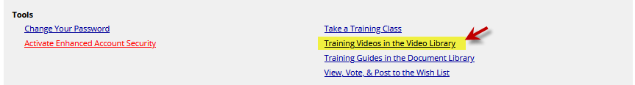

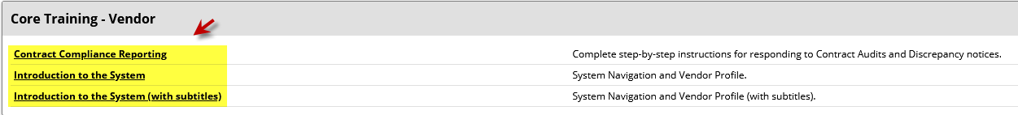

The prime contractors are responsible for entering the subcontractor payments promptly. UH HUB monitors the database and communicates any underperformance to the applicable prime contractors to ensure that they complete their contracts in accordance with their HUB Subcontracting plan. If the prime contractors failed to implement the HUB subcontracting plan in good faith, UH may bar the contractors from further contracting opportunities per Texas Government Code 2161.253.

Contact Tamika Rojas at (713)743-4283 (UH HUB Department) for additional information.

HUB Reports

The UHS/UH HUB Reports can be viewed on [the Comptroller’s website](https://comptroller.texas.gov/data/purchasing/hub/fy23/) under Section VII. State Agency Expenditure Data.