Service Center (SC) Vendor Set-Up

- Complete all sections.
- Service Center Name
- Service Center Physical Address
- Cost center string
- Speed Type
- Contact Name, email address and telephone number
- Account code to record revenue, receivable
- SC vendor creator name and employee ID
- SC vendor department approver name and employee ID
- SC vendor intermediate approver name and employee ID

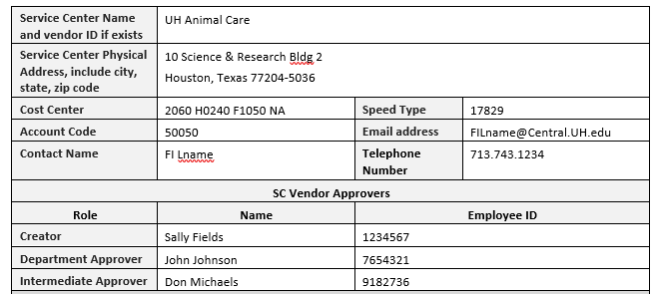

- Answer all questions in the middle section. (Click on the drop down menu for Yes or No)
- Enter any specific instructions or comments for each question in the gray field.

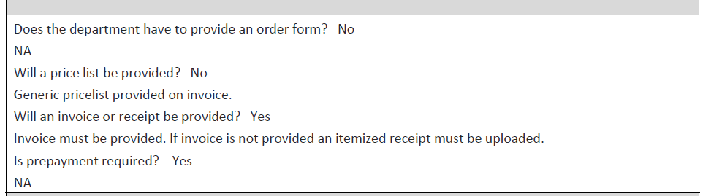

- Email the completed form to General Accounting, mdavila5@uh.edu.
- General Accounting will notify the SC vendor contact by email with the SC vendor ID.

NOTE: The last section will be completed by General Accounting and Accounts Payable.

