Interactive Lecture Demonstration – Force Exerted by a Capacitor

Before watching the video, please answer questions 1 – 3.

1. In the figure shown below, sketch the electric field lines when the arbitrary object is not near the capacitor plates.
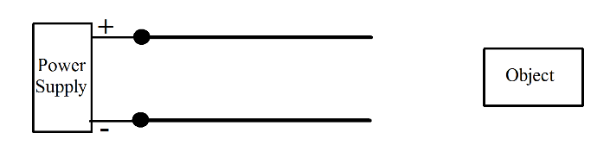

2. The arbitrary object is moved closer to the capacitor as shown. Sketch the charge distribution on the object and the electric field lines around the object.

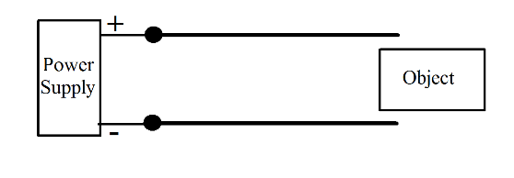

3. What is the difference between the electric field lines for a conducting object and a dielectric object?

4. Now watch the first 1 minute and 32 seconds to see how your predictions matched the experiment. Comment.

5. Watch the remaining part of the video. In the video, it is stated that k depends on geometry and the material from which the object is made. Be more specific and state the parameters on which k depends.

6. If dielectric breakdown occurs when the electric field in air is about 3 × 10⁶ V/m, and the applied voltage was about 3 kilovolts, estimate the distance between the aluminum block and the capacitor plate. Does your calculation match the geometry shown in the video?

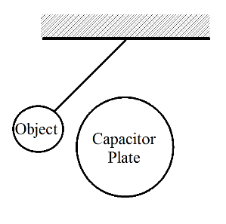
7. Suppose a circular object is attached to a rod and allowed to swing in and out of the capacitor as shown. Describe the forces acting on the object during one complete period of oscillation.

8. By whatever means you choose, show that the force on the object varies with applied voltage as shown in the video.

